Annie J. Dahlgren
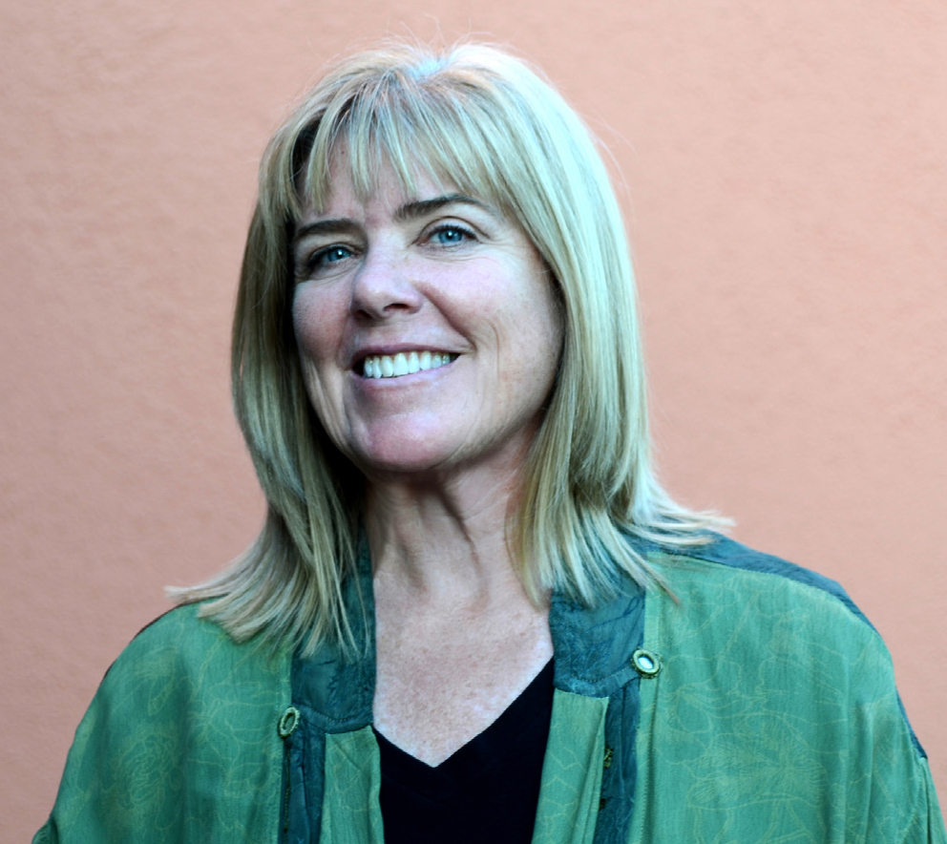
During the early years of my childhood, I remember going to church with my mom and my brother nearly every Sunday. We attended the Reorganized Church of Jesus Christ of Latter Day Saints – a name so incredibly long that no kid could possibly be expected to remember it. But I did. I could say it all in a rush when I was no more than four.
It seemed dreadfully unfair to me that my dad didn’t have to go. He got to stay in bed late and then watch TV. There were plenty of kids my age at church, and I didn’t mind the Sunday school part so much, but the regular service was unbearably boring. Mom always sat between my brother and I, lest we begin to whisper and bicker and fuss throughout the tortuous droning of the men in suits up on the little stage.
My mother’s father was a minister in that church up in Washington State where we lived before my family moved to Bakersfield in 1958. My dad had been unable to find work around the Portland/Vancouver area when he returned to his wife and two new children from the Korean conflict overseas. His brother-in-law told him that, if he would move to California, he could get him a job in the potato sheds down there. Once arrived, my dad heaved hundred-pound sacks of potatoes onto railroad cars for a couple of weeks, until his boss told him his bookkeeper had just quit. Dad lied and told his boss he knew how to do it, and then immediately turned himself into a good enough one for the job. Soon he was adding up numbers in the air-conditioned office while other young men heaved canvas sacks of potatoes in the baking sun.
When I was eight I got baptized into Mom’s church. I had no idea what that meant really, but all the grown-ups seemed very excited about the idea. And I did like the white dress with pink ribbon I was to wear for the occasion. They explained to me that we would all be going down to the Kern River and a few of us kids, and even one of the adults, would be wading into the water – in our clothes! – and one of the men in a suit would say some prayers and then dunk us under the water so we wouldn’t have any more sins. They did NOT explain that the water would be cold and be going up my nose and that my white dress would end up a big mess. I didn’t like any of it at all.
Not long after that, my mom decided the church was no longer for her. No doubt living a thousand miles away from her father aided in that decision. She cast religion far afield and we all joined my dad sleeping in and watching TV on Sundays, until he moved out when I was ten. By then my little sister had arrived and the three of us kids pretty much did whatever we wanted, now that mom had to be the dad, too.
The extent to which spirituality was absent from our lives was clearly displayed, when once, in high school, my sister’s boyfriend suggested they go see the movie “The Ten Commandments”, to which my sister replied, “Sure, okay. What’s that about?”
So that was it - the sum total of my spiritual experience (unless you count my court-mandated attendance at Alcoholics Anonymous in my late twenties, wherein I attempted to turn my troubled life over to an indistinct and ill-defined higher power for a couple of years) until my late forties. My brother had experienced some kind of awakening, and was doing his best to drag his sisters along his new path of spiritual seeking and inquiry. My interest in spirituality increased over the next several years as I learned from Eckhart Tolle, Neal Donald Walsh, Ganga Ji and many others, and participated in retreats provided by Landmark Education and the incredibly transformative Hoffman Process.
Then, at 62, I was researching the Spiritualist community in Summerland for the third installment of the Santa Barbara History Mysteries book series I’m writing that takes place in and around Santa Barbara in the late 19th and early 20th centuries. I found myself on the scotc.org website, and saw that church services began at 11:00. It was then 10:30 and so, without thinking too much about it, I headed down to the church – and as it turned out – to my new life as well.
This is the first time, as an adult, that I have experienced total belonging. To feel seen and known and understood is profoundly healing at a soul level. I’ve never known anything like it and it leaves me feeling inspired, creative and filled with a desire to serve my community of like-minded souls and the church space itself. I have learned things about life, love, the universe and myself that I could never have even imagined - and I have an excellent imagination.
I find Spiritualism joyful and fulfilling beyond measure and look forward each week to seeing every person at church. I marvel at the miracles I witness and experience over and over again. I feel overflowing with gratitude that I came stumbling into my tribe that day, and I know one thing for sure – I am blessed.
With love,
Annie J

